Text Feed Page
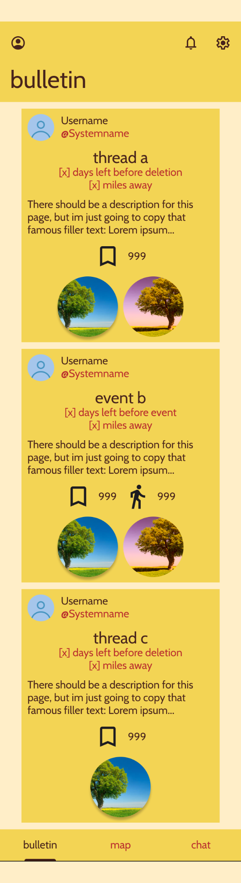

Thread Detail Page
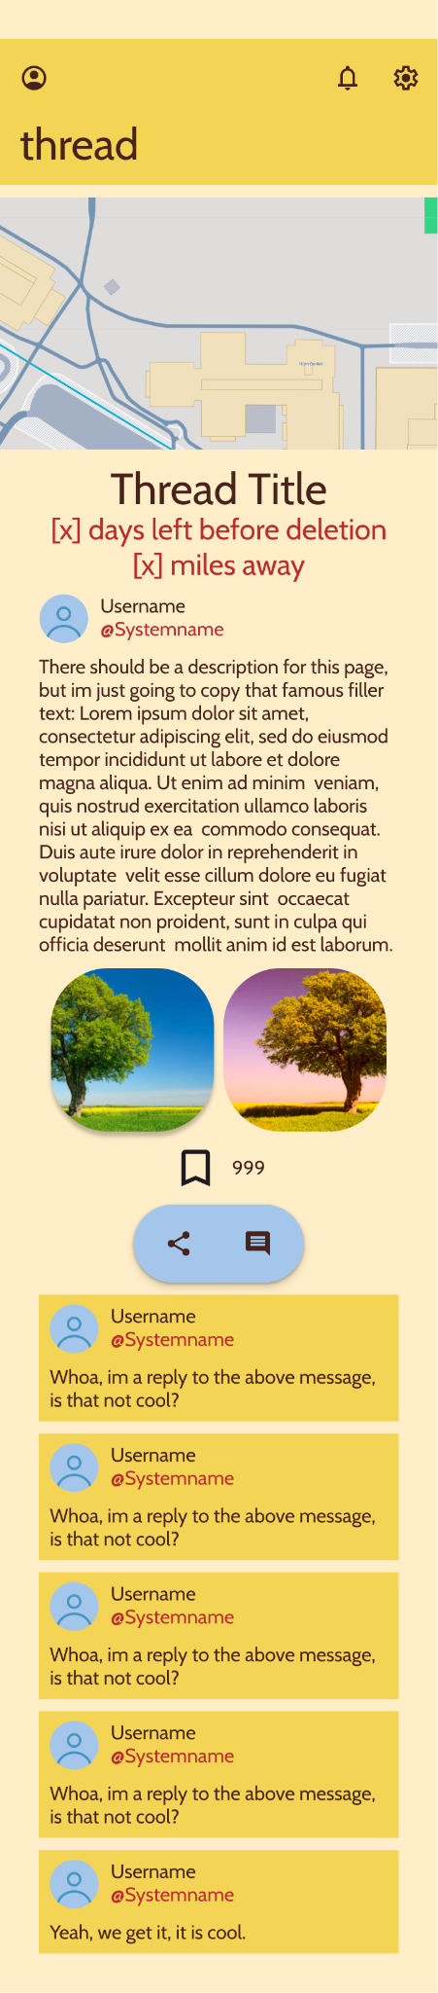

Color Palette
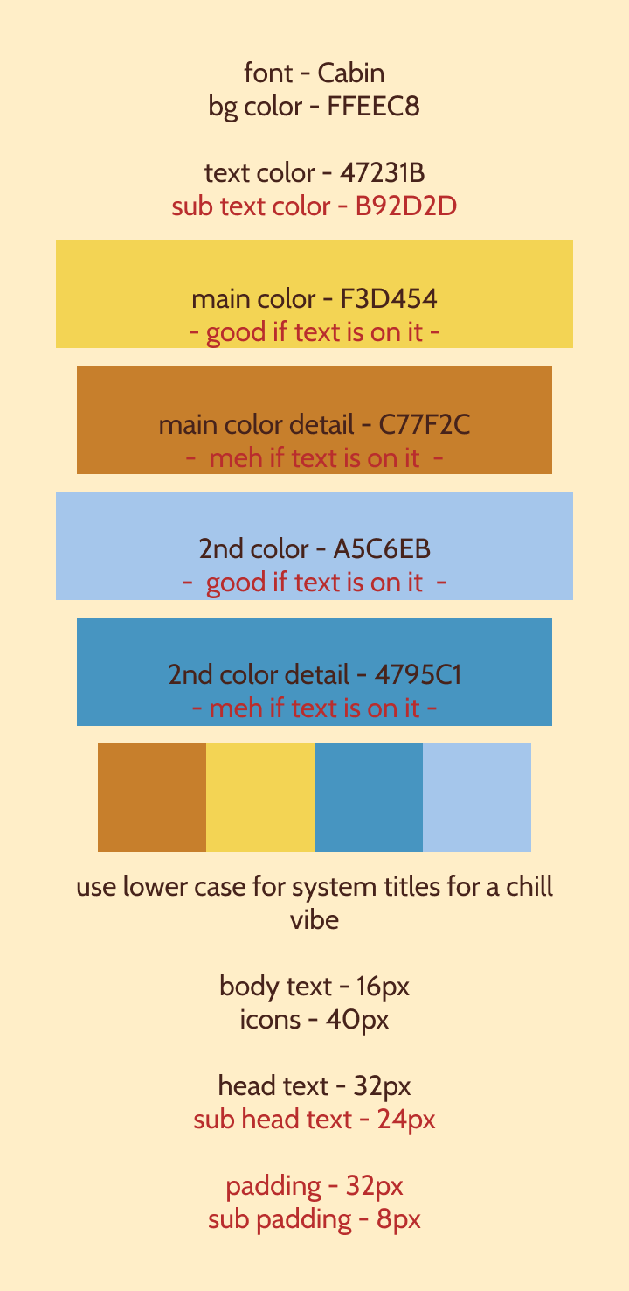

The orange colors give off a comfortable energy while.The blue can be used to highlight certain elements as needed, such as buttons, as it sticks out well off the orange hues but isn’t garish.

https://www.figma.com/design/37CNr3YCzYVguv2tlEGTSq/Milestone-1---Design-Idea-1?node-id=0-1&t=6epFnVARTfV3w0Mh-1

